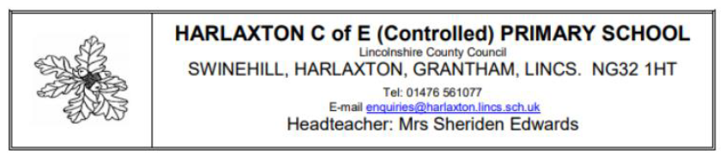
Dear Parents and Guardians,
I hope you and your family had a wonderful Christmas and a very happy New Year! I am delighted to continue as your child’s Year 1 teacher this term. We have an exciting Spring Term ahead, and our essential question is:
“Where will an adventure take you?”
The children will explore new places, discover stories, build and design, and learn about amazing explorers from the past.
Important reminders:
- School start and end: 8.50am drop-off, 3.30pm collection at the side gate.
- Water bottles: Please send a bottle with only water.
- Snacks: Fruit and vegetables provided; you may also send a healthy snack (no chocolate, crisps, or nuts).
- Lunch: Children sit together for packed lunches or hot dinners. Universal Free School Meals can be ordered via Ideal School Meals.
- Coats: Please send a coat each day as the weather is unpredictable.
- PE: Lessons on Tuesdays; PE kits stay in school.
- Homework: Handed out Fridays, returned by Wednesday (spellings, English or maths). Spellings are also on the Year 1 website if your child is absent.
- Reading: Books change weekly on Mondays. Bedtime stories are changed every Friday. Children earn house points for reading at home five times a week.
If you have any questions, please speak to me at the gate in the mornings or after school. I am looking forward to an exciting term full of learning and adventures!
Warm regards,
Miss Maksoud
Year 1 Teacher

