Welcome to
Harlaxton
Primary
School
Foundation Stage.

Welcome booklet
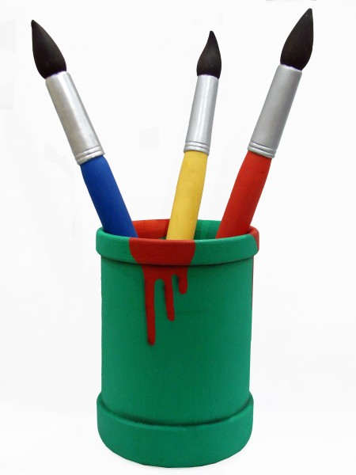
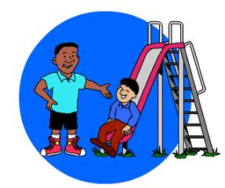


What is the Foundation Stage?
The philosophy of the EYFS is play-based learning. It has been designed specifically for children from birth until the children complete their first year at school called Reception.
During the Reception year, children will encounter new experiences where they will engage with other people and their environment. They explore the world around them, ask questions and develop their confidence to build on what they already know. Play is an integral part of this process so that learning is both challenging and fun!
My name is Mrs. Payne and I am the Reception teacher.
Mrs. Mandair is the full time Teaching assistant for Reception.


The Foundation Stage is split into seven areas of learning.

Communication and Language
Children are given opportunities to experience a language rich environment that will give them the confidence and skills in expressing themselves well. Through play and activities both indoors and outdoors, children will use language to interact with others.


Physical Development
Children are given the opportunities to use on large and small play equipment and apparatus. In the classroom they develop their fine motor skills through a range of activities including mark making, cutting and sticking, making and designing.

Personal, social and emotional development
Children are encouraged to think about the needs and feelings of themselves and others. They are given learning opportunities to become independent and feel confident in a range of contexts.


Literacy

Children are encouraged to read and write in a variety of contexts both formally and in their play. They love to read and write and are encouraged to discuss their experiences in a supportive and happy environment. The best preparation for reading is encouragement and enjoying stories in a comfortable atmosphere. Children will learn when they are ready.

*Reading
At Harlaxton, we use the Read Write Inc scheme for teaching the children phonics. We have found this to be a successful way of teaching the children their letter sounds; children are encouraged to ‘sound it out’ which is when the word is broken down into its component sounds, each sound is said separately and then blended to say the word e.g. c-a-t. cat.
Your child will be given a pack of sounds and words to practise saying and reading at home. If you find that you have any questions then please do not hesitate to come and see me.
Your child will be assigned to a day of the week. This relates to the day of the week when your child will be heard read and books/sounds will be changed where required.
A reading record folder will be issued and every time you help your child with their sound or word work, please make a comment about how they have done. If you can manage 10 minutes of Sound/reading work every day with your child it makes such a difference to the progress made during the year.
Sharing and enjoying books together is an essential stage in early reading development, it encourages conversation, understanding of text and associating written words to meaning. Even talking about pictures and guessing what may happen next is a very useful activity.

Mathematics

Through their play and activities children will learn how to count and write numbers. They begin to solve mathematical problems in practical contexts and investigate shape and space.

*To help your child with their numerical development you could encourage them to count in different situations for example when they lay the table, recognition of numbers on doors as you walk down the street and writing numbers.
Baking with your child is a fantastic way for them to learn about measures and using an egg timer or looking at where the ‘big hands’ are on the clock at the start and end of an activity can help build the early understanding of time.

Understanding the world

There is lots to see, experience and learn about in the environment and area that we live in, and the wider world. They will also develop their understanding of technology and how things change over time.

Expressive arts and design
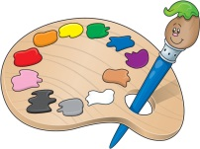
The creative part of the curriculum allows children to use their imagination to paint, model, design and create for a range of purposes. The role play area and outdoor learning opportunities give our children the chance to indulge in the creative and imaginative play of their choosing.

I will keep a Foundation Stage profile which summarises and describes your child’s achievements throughout the Reception year. It is based on ongoing observations and assessments of your child in each of the above areas and makes a lovely record of their first year at school.

Starting School
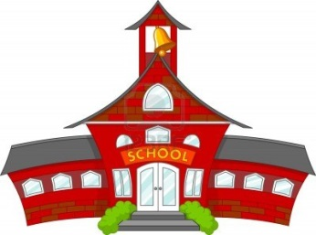
We fully appreciate that coming to school for the first time can be
a worry for both children and parents. Please be assured that we
do our best to make school a warm, welcoming, happy,
calm and comfortable place where the children can settle
quickly.

It would be a fantastic help if you could encourage your children to :
Dress themselves
Wash and dry their hands
Fasten their shoes and coat
Cope with toilet needs – Your child will be allowed to go to the toilet whenever they need, as long as they ask the teacher first. Do not worry if your child has an accident in school. Please be assured that it is quite common that an accident may occur. We have some spare uniform that they can be changed into, which we will then ask parents to wash and return to school. Alternatively, you can send a spare set of clothes to be kept on the child’s peg.
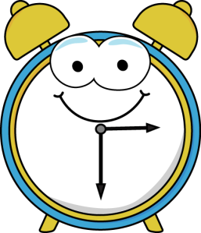
Coming into school and going home
The school day begins at 9.00am and ends at 3.30pm.
Doors will open for you to come in at 8.50am.
Please bring your child into the cloak-room.
Each child will be given a peg to hang their coats and bags.
You are welcome to join your child in the classroom for ten minutes to help them with their starter activities.

Please advise the school if someone different will be collecting your child.

Each day your child will need to bring with them:
- Book Bag
- Lunch (unless staying for hot lunch)
- Water Bottle
- Suitable outdoor clothing
- Please could you make sure that all your child’s items are clearly labelled with their name. This helps us find them if they go missing.

Set up of the day
The first few weeks coming into school will mainly focus on familiarising the children with the daily life and routines of the school. The setup of a typical day falls as follows:
8:50 – School begins

10:30 – Assembly
10:45 – 11:00 Morning playtime
12:00 – Lunchtime
1pm – Afternoon begins
2:45 – 3pm – Afternoon playtime
3:20-3:30pm – Home time.


Lunchtimes and snacks
We offer hot meals which are provided by the Farm Kitchen. A meat and vegetarian option is offered daily. Children who do not wish to have a hot meal may bring a packed lunch or go home for lunch. No fizzy drinks, cans or bottles please. We are trying to be ‘Healthy School’ so please send your child with a healthy balanced selection of foods.

All children are encouraged to have a water bottle in school, to which they have access throughout the day. These may be purchased from school if you wish. Children in Reception are offered a free piece of fruit at break time
and children under 5 years are offered a free carton of milk each day.

If your child has any allergies, please inform the school on your registration form and also the teacher. You will be notified if we are doing any baking or food tasting in the class and you can highlight again any food allergies or intolerances that your child may have.

Illness and Accidents
If your child has a minor accident at school they will receive first aid from a qualified member of staff and you will receive a note in their book bag to inform you of their accident. If their accident is more serious or they have received a severe bang to the head then you will be informed immediately so the appropriate next steps can be made.
Please notify us immediately if any of your emergency contact details change.

Medication

You are welcome to come into school to administer medication to your child if they need it. Please contact the school office or refer to the school brochure for further advice if your child needs to be given medication.
Please contact us if your child has any medical problems.

Sun cream
As Reception spend a lot of time outside, when the weather is warm, it may be a good idea to provide your child with sun cream that they can apply themselves throughout the day. Please label their sun cream bottle and keep it in their bag. Or ensure that your child has sun cream on before coming to school.

PE
Children will have many opportunities to enhance their physical development. One of these will be through a teacher led PE session at least once a week. Parents are asked to provide suitable t-shirts, shorts and plimsolls for PE. Printed red t-shirts are available from school on request as are PE bags.

ALL jewellery and earrings must be removed for PE. Staff may not remove earrings, please ensure your child can take them out or remove them before coming to school.

Communication
We believe that communication is vitally important so that you are kept informed about school life and events. The school will communicate with you via emails, parentmail, sending letters, newsletters, phone calls and via the website.

As the Reception teacher my main form of communication with you will be via letters, newsletters and notes so please ensure that you check your child’s book bag regularly. Open evenings are held twice a year to facilitate feedback and discuss your child’s progress, however please do come and speak with me at any time should you have any concerns, thoughts or ideas. Some home/school communication sheets will be available so you can inform us of any of your child’s interests or developments they have made out of school.

Labelling
Please put name labels on ALL of your child’s clothing, shoes, bags and coats and encourage your child to recognise their own name and belongings. As you can imagine, things can easily get lost, particularly when there are 30 little people getting changed for PE!
Homework

Initially homework will consist of initial sounds and words moving and then onto reading books when your child is ready. Your child will later be issued with a homework book where any work given will reinforce the learning covered in that week.
School Nurse
Whilst your child is in reception they will be visited by the school nurse to check their height, weight and hearing.

Finally we would like to reassure you that we know there is lots of information to take in and that we are all on hand to answer your questions or discuss any element of your child’s care and progress.

